**Implementation**

1-append function

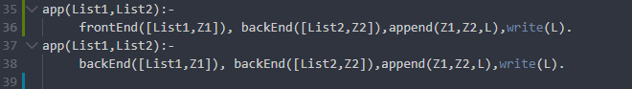

This take list1 append to list 2

2- Delete Function

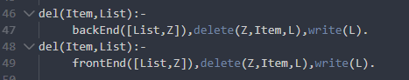

This take item and list content item and remove it

3- faster Function t

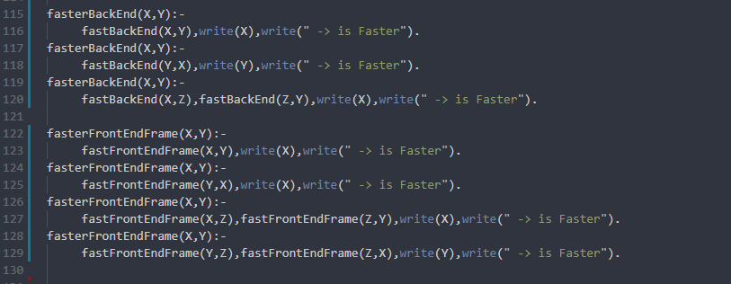

This take 2 programing langue or framework and compare how is faster

4- index of function

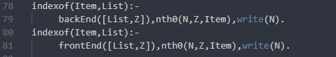

This function find the index number of list

5- is Empty Function

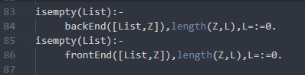

This check if the list is empty or not

6- last Function



This get the last item in the list

7-length function



This return the length of the list

8- max function

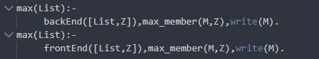

This ill return the larger item in list

9-min Function

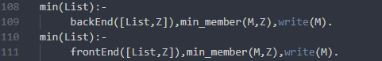

This will return the smallest item in list

L 10- on function

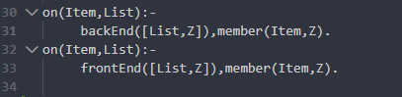

Check list content this item or not

11-reverse function

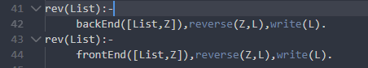

12- search

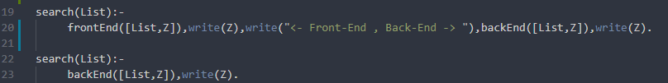

This function search about list and if found it returns all list items

L13- more secoure

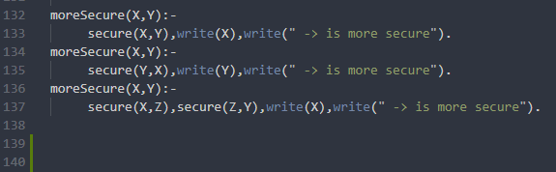

This take 2 pregaming language ands compare how’s more secure

14-select function

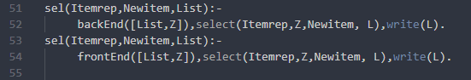

This update item list by take list name and item and new item value

15- sort

